Compact Zirconia Cylindrical Dielectric Resonator Antenna for 5.8 GHz Next-Generation Wireless Communication
Bagavath Kumar P., Jyotilipsa Mishra, Adhil Anil Pillai, Om Prakash Shinde, Ameet Mehta
Department of Electronics and Telecommunication Engineering
Pillai College of Engineering (Autonomous), Navi Mumbai, India

Abstract—Dielectric resonator antennas (DRAs) avoid the conductor and surface-wave losses of microstrip patches, yet nearly every reported DRA uses alumina as its resonator. This paper proposes a microstrip-fed cylindrical DRA that uses zirconia (ZrO₂, ε_{r} = 23) as the dielectric resonator for the 5.8 GHz wireless band. The work began with a review of twenty DRA papers: twelve name alumina as the resonator material and none uses zirconia. A circular inset-fed patch on FR-4 was first designed at 5.8 GHz as a baseline. A zirconia cylinder only 12.4 mm in diameter and 10 mm high was then designed on a 60 × 60 × 1.6 mm³ FR-4 board, and an alumina (ε_{r} = 9.9) DRA was designed on the same board and feed for a like-for-like comparison. Simulated in Ansys HFSS, the zirconia DRA resonates at 5.767 GHz with a −50.25 dB reflection coefficient (VSWR 1.006), an 81 MHz −10 dB bandwidth, 85.6 % radiation efficiency, a broadside beam with 6.8 dBi directivity, and a realized gain of 5.9 dBi that peaks at 7.85 dBi at 5.82 GHz. Compared with the alumina DRA on the same platform, the zirconia resonator occupies 94 % less volume, is 17 percentage points more efficient and gives 1.1 dB more gain at resonance; compared with the patch, it is 25.7 points more efficient with 2.1 dB more gain. A multiband extension with a concentric 12-sided zirconia parasitic ring, matched at 4.05, 5.02, 5.84 and 8.20 GHz, is outlined as future scope.
Keywords—Dielectric resonator antenna (DRA), Zirconia, Alumina, Cylindrical DRA, 5.8 GHz WLAN, miniaturization, parasitic ring, HFSS.
I. Introduction
Next-generation wireless systems, such as Wi-Fi in the 5.725–5.875 GHz band, sub-6 GHz 5G and Internet-of-Things (IoT) links, need antennas that are compact, efficient and easy to integrate. Microstrip patches remain the default because they are cheap and planar, but their metallic radiators suffer conductor and surface-wave losses that lower the efficiency, especially on low-cost substrates such as FR-4. Dielectric resonator antennas (DRAs) instead radiate from a low-loss ceramic block, have no conductor loss in the radiator, and give the designer freedom in shape, feed and material [1]. This work grew out of a staged study of twenty DRA papers, summarized below, which led to zirconia being chosen as the resonator material.
In the first stage, eight papers on DRA fundamentals and enhancement techniques were studied. Mukherjee et al. [1] review DRA modes, feeding methods, geometries, miniaturization, circular polarization, MIMO and arrays. Moni et al. [2] simulated a cylindrical DRA of (Zr_{0.8}Sn_{0.2})TiO₄ (ZST, ε_{r} ≈ 36) and varied ε_{r} from 15 to 45: the resonance fell from 3.74 to 2.99 GHz and the −10 dB bandwidth narrowed from 160 to 70 MHz, which is the size–bandwidth trade-off of high permittivity. Dave et al. [3] showed that a simple rectangular DRA simulated in HFSS can serve 5G bands at 8.3 and 11.6 GHz. Ali et al. raised gain and bandwidth together by exciting a higher-order mode in a perforated DRA, reaching 9.3 dBi and 96 % efficiency at 26 GHz [4], and by hollowing the resonator to lower its Q, giving a 16.1 % measured bandwidth at 15 GHz [5]. Al-Alem et al. [6] surrounded a 60 GHz DRA with a dielectric ring to raise its boresight gain and pattern symmetry. Zhang et al. [7] surveyed DRA technology for 5G and 6G, including LTCC/PCB integration and beam-steering arrays, and Srivastava et al. [8] paired a dual-band circularly polarized DRA of stacked alumina cylinders (111.1 % bandwidth, 12.8 dBic) with machine-learning performance prediction. Moni's observation that a higher permittivity shrinks the resonator, together with the absence of zirconia from these papers, led the authors to select zirconia (ε_{r} ≈ 23–30) as the resonator material.
A second, material-focused review of twelve papers then showed how strongly alumina dominates. Cylindrical alumina DRAs include the 4.16 GHz CDRA of Surendra and Khan [9] (Ø20 × 10 mm, ε_{r} = 9.9, 7.36 dBi directivity), the 4 GHz CDRA of Goutia and Tiwari [10] (6.8 dBi, 3.4–5 GHz), the 2.4 GHz glucose-sensing CDRA of Upadhyay et al. [11], whose 3.6 dBi gain rises to 7.69 dBi with an artificial magnetic conductor (AMC), the differentially fed 2 × 2 alumina CDRA array of Hasan et al. [12] covering 5.78–5.90 GHz with 11.07 dBi, and the partially grounded multiband CDRA of Prasanth and Guruviah [13] covering 2–6 GHz. He et al. [14] loaded a CDRA (ε_{r} = 9) with a concentric annular column (ε_{r} = 16) to merge four modes into a 56 % bandwidth. Other alumina shapes include the dual-band rectangular DRA of Ashaari et al. [15] (7.57 dB measured at 7 GHz), the perforated star-shaped DRA of Girjashankar and Upadhyaya [16] with three bands between 5.04 and 9.63 GHz, 3.71–8.10 dBi and 82 % efficiency, and the four-port MIMO DRA of Patel and Upadhyaya [17] (5.8/6.2 dBi and about 90 % efficiency at 3.3/3.9 GHz). Pan et al. [18] built a circularly polarized Al₂O₃ DRA array with 53.2 % impedance bandwidth and 12.48 dBic, Trinh-Van et al. [19] used a genetic algorithm to shape a pixelated alumina DRA (6.13 dBic), and Omar et al. [20] stacked Al₂O₃, SiO₂ and MgZrO₃ half-cylinders for a 61.01 % bandwidth from 11.96 to 22.46 GHz.
Taken together, alumina is the resonator in twelve of the twenty papers. Zirconium appears only inside compounds, as ZST in [2] and as one MgZrO₃ layer in [20], and zirconia itself is not used as a resonator in any of them. Outside this set, zirconia has been used as a thin flexible antenna substrate (ε_{r} ≈ 22) [21] and, recently, in 3D-printed DRAs for space [22] and for 2.45 GHz MIMO terminals (ε_{r} = 23, tan δ = 0.0015) [23]. To the best of the authors' knowledge, a simple microstrip-fed solid zirconia cylindrical DRA for the 5.8 GHz band, compared directly with an alumina resonator on the same board and feed, has not been reported. Zirconia suits this role: its permittivity of about 22–30 [21], [23], [24] is two to three times that of alumina, which shrinks the resonator, and yttria-stabilized grades reach flexural strengths of 951–1380 MPa against 340 MPa for alumina [18], [24], so a small resonator is also robust.
The contributions of this paper are: (i) a circular inset-fed patch at 5.8 GHz as a planar baseline; (ii) a compact zirconia cylindrical DRA for 5.8 GHz; (iii) an alumina DRA on the identical board and feed for a like-for-like comparison; (iv) a comparison with alumina DRAs from the literature; and (v) a multiband zirconia DRA with a 12-sided parasitic ring as future scope. Section II describes the designs, Section III discusses the results, Section IV presents the multiband extension and Section V concludes the paper.
II. Antenna Design
A. Design Flow and Common Platform
All designs were modelled and simulated in Ansys HFSS. Every antenna uses a 1.6 mm FR-4 substrate (ε_{r} = 4.4, tan δ = 0.02) with a copper ground plane on the bottom face and a 3 mm wide microstrip feed on the top face. The design followed four stages: a circular patch at 5.8 GHz as the reference; the proposed zirconia DRA; an alumina DRA on the same 60 × 60 mm² board; and finally a multiband zirconia DRA with a parasitic ring (Section IV).
B. Resonator Material
Table I compares the two ceramics. In HFSS, alumina was assigned ε_{r} = 9.9, the value used in [9] and [17], and zirconia ε_{r} = 23, the lower end of its 23–30 range and the value used for the printed zirconia of [23]; both were given tan δ = 0.002. For a cylindrical DR of fixed aspect ratio, the resonant frequency of the dominant broadside mode scales as [9], [10]
$f_{r}∝\frac{c}{2πa\sqrt{ε_{r}+2}}$ (1)
where a is the DR radius and c is the speed of light. At a fixed frequency the radius therefore scales as 1/√(ε_{r} + 2), so replacing alumina with zirconia should shrink every dimension by
$\frac{a_{Zr}}{a_{Al}}=\sqrt{\frac{ε_{r,Al}+2}{ε_{r,Zr}+2}}=\sqrt{\frac{11.9}{25}}≈0.69$ (2)
and the volume by about 0.69³ ≈ 0.33, a reduction of roughly two-thirds. Zirconia is denser and conducts heat less well than alumina (Table I), but, as Section III shows, the smaller volume more than offsets the higher density.
TABLE I
Properties of the Two Resonator Materials
Property | Alumina (Al₂O₃) | Zirconia (ZrO₂)
ε_{r} used in HFSS | 9.9 | 23
tan δ used in HFSS | 0.002 | 0.002
Typical ε_{r} | 9.5–9.9 [9], [18] | 22–30 [21], [24]
Density (g/cm³) | 3.9 [18] | 5.7–6.2 [24]
Flexural strength (MPa) | 340 [18] | 551–1380 [24]
Thermal conductivity (W/m·K) | 27 [18] | 2.2–3.5 [24]

C. Reference Circular Microstrip Patch
The baseline is an inset-fed circular patch on a 27 × 24 × 1.6 mm³ FR-4 board (Fig. 2(a)). Its radius follows the cavity-model design equations [25]
$a=\frac{F}{\sqrt{1+\frac{2h}{πε_{r}F}\left[ln\left(\frac{πF}{2h}\right)+1.7726\right]}}$ (3)
$F=\frac{8.791×{10}^{9}}{f_{r}\sqrt{ε_{r}}}$ (4)
where F and h are in centimetres. For f_{r} = 5.8 GHz, ε_{r} = 4.4 and h = 0.16 cm, (3) and (4) give a ≈ 6.8 mm; the simulated patch uses a = 6.7 mm. Two 0.5 mm wide, 8 mm long inset slots on either side of the 3 mm feed set the input match.
D. Proposed Zirconia Cylindrical DRA
Fig. 1 shows the geometry and HFSS model of the proposed antenna. A zirconia cylinder 12.4 mm in diameter and 10 mm high sits at the centre of a 60 × 60 × 1.6 mm³ FR-4 board, and the 3 mm microstrip line runs from the board edge to the rim of the cylinder, which it excites directly. The DR dimensions were chosen to resonate in the 5.8 GHz band. At 5.767 GHz (λ₀ = 52.0 mm) the resonator is only 0.24λ₀ across and 0.19λ₀ high.
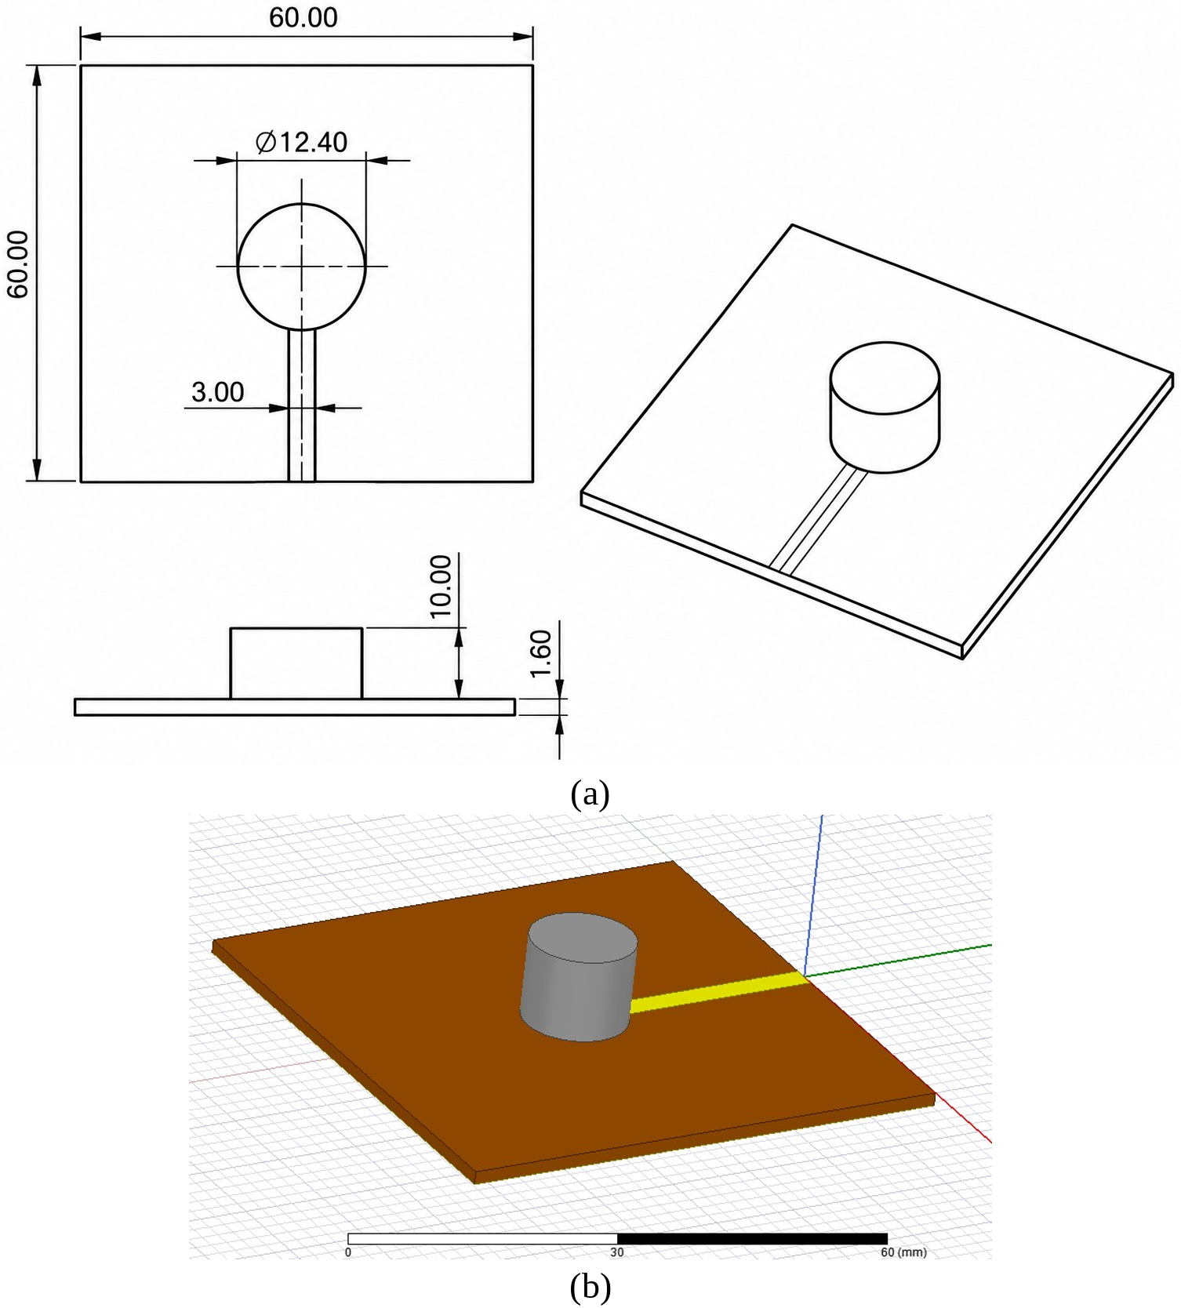
Fig. 1. Proposed zirconia cylindrical DRA: (a) geometry with dimensions in mm (top, side and isometric views), (b) HFSS simulation model on the 60 × 60 mm² FR-4 board with the 3 mm microstrip feed.
E. Alumina Cylindrical DRA
To isolate the effect of the material, the alumina DRA (Fig. 2(b)) keeps the same board, ground plane, feed width and band. Only the resonator changes: an alumina cylinder 42.4 mm in diameter and 15 mm high, which resonates at 5.769 GHz. Table II lists the dimensions of all three antennas.
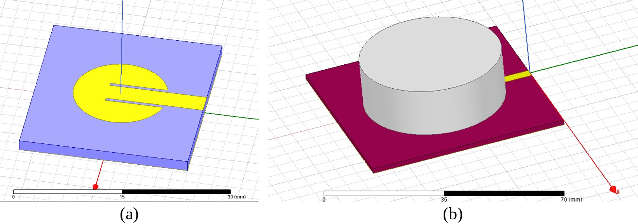
Fig. 2. HFSS models of the reference designs: (a) inset-fed circular patch on 27 × 24 mm² FR-4, (b) alumina cylindrical DRA on the same 60 × 60 mm² FR-4 board as the zirconia DRA.
TABLE II
Dimensions of the Designed Antennas (mm)
Parameter | Patch | Zirconia DRA | Alumina DRA
Substrate (L × W × h) | 27 × 24 × 1.6 | 60 × 60 × 1.6 | 60 × 60 × 1.6
Feed-line width | 3 | 3 | 3
Radiator radius | 6.7 | 6.2 | 21.2
Resonator height | — | 10 | 15
Inset slots (l × w) | 8 × 0.5 | — | —
Material (ε_{r}) | Copper | ZrO₂ (23) | Al₂O₃ (9.9)
Resonator volume (mm³) | — | 1 208 | 21 179

III. Results and Discussion
A. Impedance Matching
Fig. 3(a) compares the simulated reflection coefficients, and Table III summarizes the key figures. The zirconia DRA resonates at 5.767 GHz with |S₁₁| = −50.25 dB, the deepest match of the three designs, and a VSWR of 1.006 (0.0534 dB). Its −10 dB band spans 5.726–5.807 GHz (81 MHz, 1.41 %), about twice the 39.5 MHz (5.754–5.793 GHz, 0.68 %) of the alumina DRA, which reaches −25.07 dB at 5.769 GHz (VSWR ≈ 1.12) and shows a weaker second resonance near 5.90 GHz. The patch reaches −15.95 dB at 5.827 GHz (VSWR ≈ 1.38) and has the widest band, 5.753–5.900 GHz (147 MHz, 2.52 %), as expected from its lossy, low-Q FR-4 radiator. The narrower band of the zirconia DRA follows the trend reported by Moni et al. [2]: a higher permittivity stores more energy and raises the Q. Its band covers the lower 81 MHz of the 5.725–5.875 GHz allocation; the parasitic-ring design of Section IV widens the 5.8 GHz band to 283 MHz.
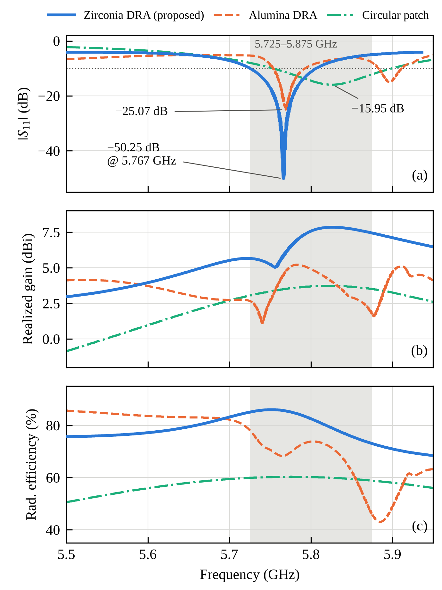
Fig. 3. Simulated comparison of the zirconia DRA, alumina DRA and circular patch: (a) |S₁₁|, (b) realized gain and (c) radiation efficiency. The shaded strip marks the 5.725–5.875 GHz band; the dotted line marks −10 dB. Traces are re-plotted from the HFSS results.
TABLE III
Simulated Performance of the Three Antennas
Parameter | Patch | Alumina DRA | Zirconia DRA
Resonant frequency (GHz) | 5.827 | 5.769 | 5.767
Minimum |S₁₁| (dB) | −15.95 | −25.07 | −50.25
VSWR at resonance | 1.38 | 1.12 | 1.006
−10 dB band (GHz) | 5.753–5.900 | 5.754–5.793 | 5.726–5.807
Bandwidth (MHz / %) | 147 / 2.52 | 39.5 / 0.68 | 81 / 1.41
Realized gain at f_{r} (dBi) | 3.7 | 4.7 | 5.9
Peak realized gain (dBi) | 3.7 | 5.2 | 7.85
Radiation efficiency at f_{r} (%) | 59.9 | 68.5 | 85.6
Peak directivity, 3D (dBi) | 6.1 | 6.4 | 6.8
Main beam | Broadside | Off-axis | Broadside
Radiator volume (mm³) | — | 21 179 | 1 208

B. Gain and Radiation Efficiency
Figs. 3(b) and 3(c) plot the realized gain and radiation efficiency. At resonance the zirconia DRA has a realized gain of 5.9 dBi and a radiation efficiency of 85.6 %; across its −10 dB band the gain stays within 5.0–7.7 dBi and the efficiency within 82–86 %, and the gain peaks at 7.85 dBi at 5.82 GHz. At its resonance the alumina DRA gives 4.7 dBi and 68.5 % (peak 5.2 dBi at 5.78 GHz), while the patch gives 3.7 dBi and 59.9 %. The zirconia resonator therefore radiates 17.1 and 25.7 percentage points more efficiently than the alumina DRA and the patch, with 1.1 dB and 2.1 dB more gain. The lower efficiency of the patch reflects the conductor and FR-4 losses of a metallic radiator, which the DRA avoids [1]; its smaller 27 × 24 mm² ground plane also accounts for part of its lower gain.
C. Radiation Patterns
Fig. 4 shows the normalized patterns in the φ = 0° and φ = 90° planes at resonance. The zirconia DRA radiates a single broadside beam with its maximum at θ = 0° in both planes, a peak directivity of 6.8 dBi in the 3D pattern and a back lobe about 11 dB below the main beam. The alumina DRA, whose resonator is about 0.82λ₀ across, instead has a null at boresight and lobes tilted roughly 40°–60° off axis, consistent with a higher-order mode in an electrically large resonator; its 3D peak directivity is 6.4 dBi, but not in the broadside direction. The patch is broadside with 6.1 dBi peak directivity. For access-point and point-to-point links that expect a broadside beam, the zirconia DRA is therefore the most suitable of the three.
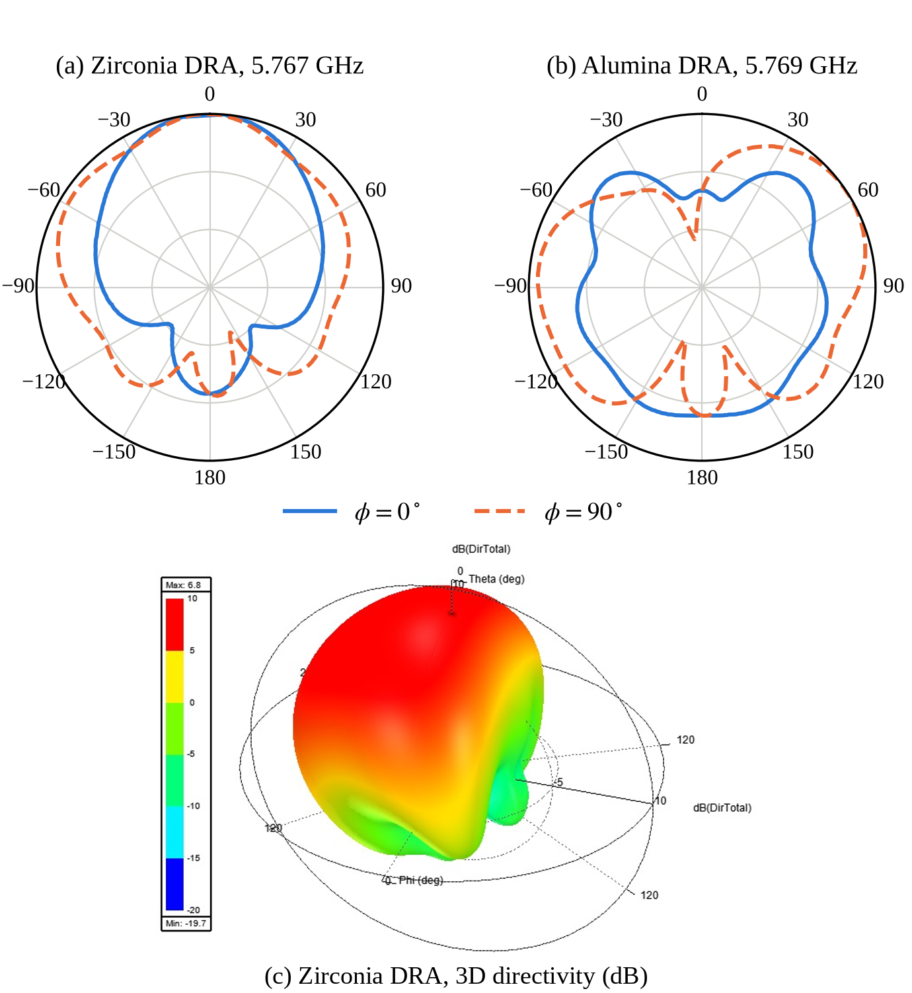
Fig. 4. Simulated normalized radiation patterns in the φ = 0° and φ = 90° planes at resonance: (a) zirconia DRA, (b) alumina DRA (radial grid 10 dB per division, outer ring 0 dB); (c) 3D directivity pattern of the zirconia DRA (peak 6.8 dBi), from HFSS.
D. Comparison with Reported Alumina DRAs
Table IV places the zirconia DRA beside alumina DRAs from the reviewed literature, and three points stand out. First, size: the closest same-band design is the alumina CDRA element of Hasan et al. [12] (ε_{r} = 10, Ø20 × 10 mm) at 5.84 GHz. The zirconia cylinder has the same height but 61.6 % less footprint and volume, close to the two-thirds reduction predicted by (2). Against the alumina DRA on our own board the saving is 94.3 % in volume and 33 % in height. Despite its higher density, the zirconia DR weighs about 7.3 g, against about 12.3 g for a solid alumina cylinder the size of [12] and about 83 g for our alumina DR.
Second, radiation: the 5.9 dBi realized gain at resonance (7.85 dBi peak in band) is comparable to or higher than that of single-element alumina DRAs such as [11] (3.6 dBi without the AMC), [16] (3.71 dBi in its 5.04–6.13 GHz band) and [17] (5.8–6.2 dBi), while [10] and [15] reach 6.8 dBi and 7.57 dB only with much larger resonators. The 85.6 % efficiency matches the 82–90 % of [9], [16] and [17] even though the zirconia DRA sits on lossy FR-4, and its −50.25 dB match is deeper than the −41 dB [2] and −29.9 dB [10] reported for single cylindrical DRAs.
Third, the trade-off: the price of the higher permittivity is bandwidth. The 1.41 % band is narrower than that of wideband alumina designs such as [10] and [16] (20.76 %), which rely on larger, perforated or reshaped resonators. For narrowband 5.8 GHz Wi-Fi, ISM and IoT links this is acceptable, and Section IV shows that a parasitic ring restores a wider band.
TABLE IV
Comparison with Alumina DRAs in the Reviewed Literature
Ref. | DR type | ε_{r} | DR size (mm) | f (GHz) | BW | Gain (dBi) | η (%)
[9] | CDRA | 9.9 | Ø20 × 10 | 4.16 | — | 7.36† | 83
[10] | CDRA | — | Ø20 × 11 | 4.0 | 38 % | 6.8 | —
[11] | CDRA | 9.9 | 30 × 30 × 6‡ | 2.4 | 300 MHz | 3.6 | —
[12] | CDRA array | 10 | Ø20 × 10 | 5.84 | 2.1 % | 11.07§ | —
[15] | RDRA | 9.8 | 40 × 12 × 12 | 7.0 | 4.38 % | 7.57 | —
[16] | Star DRA | 9.8 | 50 × 50 × 7.6‡ | 5.04–6.13 | 20.76 % | 3.71 | 82
[17] | MIMO DRA | 9.9 | 12 × 12 × 10 | 3.3/3.9 | — | 5.8/6.2 | 88.6/90.2
This work (Al₂O₃) | CDRA | 9.9 | Ø42.4 × 15 | 5.769 | 0.68 % | 4.7 | 68.5
This work (ZrO₂) | CDRA | 23 | Ø12.4 × 10 | 5.767 | 1.41 % | 5.9 | 85.6
All literature resonators are alumina. † Directivity. ‡ Overall antenna size. § Gain of the 2 × 2 array. — Not reported.
IV. Future Scope: Multiband Zirconia DRA
To widen the band and add further bands, a parasitic ring was placed around a zirconia cylinder (Fig. 5(a)), following the ring loading of [6] and the annular loading of [14]. The central zirconia cylinder has a radius of 8.3 mm and a height of 12 mm. A concentric 12-sided zirconia ring of the same height surrounds it, with an inner radius of 12 mm and a circumradius of 15 mm (28.98 mm across flats, 7.76 mm sides), leaving a 3.7 mm gap. The 3 mm feed line, 35 mm long, passes under the ring to reach the central cylinder on the same 60 × 60 × 1.6 mm³ FR-4 board.
Fig. 5(b) shows the simulated |S₁₁| from 1 to 9 GHz. The structure is well matched at 4.05 GHz (−27.7 dB, 3.95–4.15 GHz), 5.02 GHz (−25.5 dB, 4.97–5.08 GHz), 5.84 GHz (−25.60 dB) and 8.20 GHz (−25.1 dB), with weaker resonances between 6.1 and 8.8 GHz. Around 5.8 GHz the −10 dB band now spans 5.65–5.93 GHz (283 MHz, 4.9 %), covering the whole 5.725–5.875 GHz allocation, with a realized gain of up to 7.6 dBi, an efficiency of up to 84 % and a near-broadside pattern at 5.84 GHz. In the 4 GHz band the efficiency is about 88–91 % with 4.5–6.6 dBi gain, but above 8 GHz it falls to about 25 %. Future work will tune the ring size and gap to balance the bands, identify the mode behind each band, and fabricate and measure zirconia prototypes, including by 3D ceramic printing [22], [23].
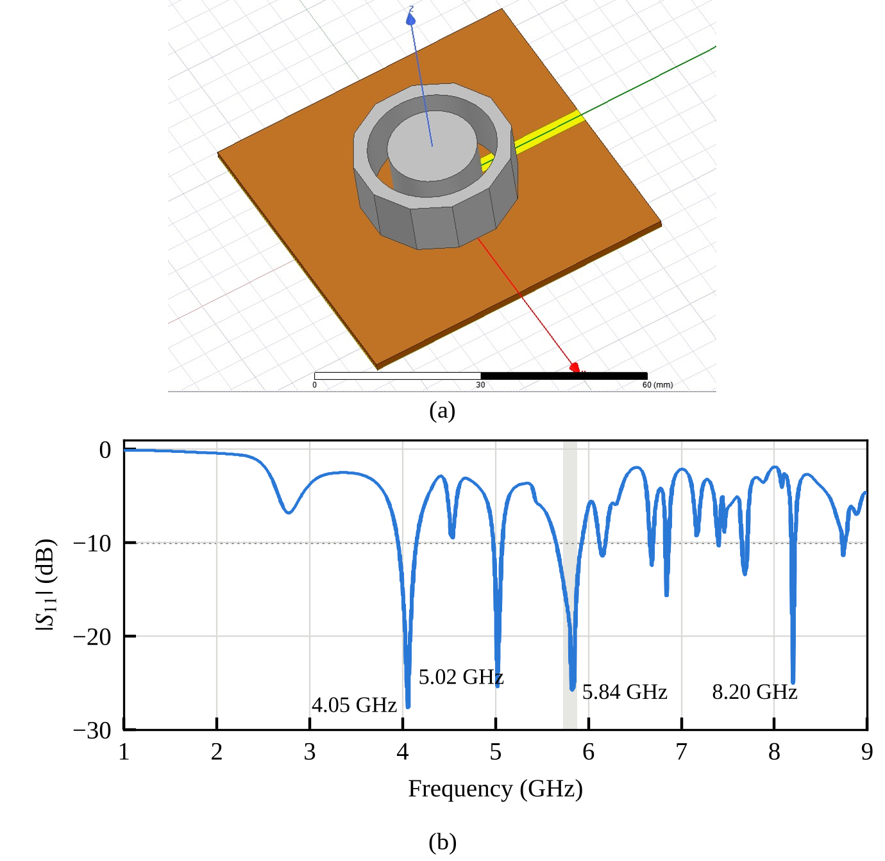
Fig. 5. Multiband zirconia DRA with a 12-sided parasitic ring: (a) HFSS model, (b) simulated |S₁₁| from 1 to 9 GHz (re-plotted from HFSS; the shaded strip marks 5.725–5.875 GHz).
V. Conclusion
A compact zirconia cylindrical DRA for the 5.8 GHz band has been designed and compared, on the same FR-4 board and feed, with an alumina DRA and with a circular microstrip patch. A review of twenty DRA papers showed that alumina dominates the choice of resonator material while zirconia had not been used, and the simulations show that zirconia's higher permittivity pays off. A Ø12.4 × 10 mm zirconia resonator, 94 % smaller than the alumina design on the same board and about 62 % smaller than a same-band alumina element from the literature, achieves |S₁₁| = −50.25 dB, 85.6 % radiation efficiency, a realized gain of 5.9 dBi at resonance (7.85 dBi peak) and a clean broadside beam. The cost is a narrower 81 MHz bandwidth, which the proposed parasitic-ring extension addresses with four matched bands and a 283 MHz band at 5.8 GHz. Together with its mechanical toughness, this makes zirconia a strong candidate for compact and rugged next-generation wireless devices. Fabrication and measurement are the next steps.
References
[1] B. Mukherjee, P. Patel, and J. Mukherjee, “A review of the recent advances in dielectric resonator antennas,” J. Electromagn. Waves Appl., vol. 34, no. 9, pp. 1095–1158, 2020, doi: 10.1080/09205071.2020.1744484.
[2] M.-V. Moni, M.-G. Turcan, L. Tuţă, I.-V. Grecu, and G. Banciu, “The influence of the dielectric constant in dielectric resonator antennas,” in Proc. Int. Conf. Commun. (COMM), Bucharest, Romania, 2016, pp. 111–114.
[3] D. Dave, J. Trivedi, and M. P. Patel, “Rectangular dielectric resonator antenna (RDRA) contributed to 5G technology,” in Proc. 3rd Int. Conf. Converg. Technol. (I2CT), Pune, India, 2018, pp. 1–4.
[4] I. Ali, M. H. Jamaluddin, M. R. Kamarudin, A. Gaya, and R. Selvaraju, “Wideband and high gain dielectric resonator antenna for 5G applications,” Bull. Electr. Eng. Inform., vol. 8, no. 3, pp. 1047–1052, Sep. 2019, doi: 10.11591/eei.v8i3.1592.
[5] I. Ali, M. H. Jamaluddin, A. Gaya, and H. A. Rahim, “A dielectric resonator antenna with enhanced gain and bandwidth for 5G applications,” Sensors, vol. 20, no. 3, Art. no. 675, 2020, doi: 10.3390/s20030675.
[6] Y. Al-Alem, A. A. Kishk, and Y. M. M. Antar, “Enhanced DRA gain by a dielectric ring for millimeter-wave applications,” in Proc. IEEE Asia-Pacific Microw. Conf. (APMC), 2020, pp. 357–359, doi: 10.1109/APMC47863.2020.9331440.
[7] Y. Zhang, S. Ogurtsov, V. Vasilev, A. A. Kishk, and D. Caratelli, “Advanced dielectric resonator antenna technology for 5G and 6G applications,” Sensors, vol. 24, no. 5, Art. no. 1413, 2024, doi: 10.3390/s24051413.
[8] U. Srivastava, S. Gupta, P. Kumari, and U. Patri, “Dual-band circularly polarized dielectric resonator antenna with wide impedance bandwidth and machine learning-assisted performance prediction,” Results Phys., vol. 79, Art. no. 108531, 2025, doi: 10.1016/j.rinp.2025.108531.
[9] L. Surendra and H. Khan, “Design and analysis of cylindrical dielectric resonator antenna for 5G application,” Int. J. Eng. Adv. Technol., vol. 10, no. 2, pp. 116–118, Dec. 2020, doi: 10.35940/ijeat.B2042.1210220.
[10] A. Goutia and G. Tiwari, “CDRA with super high frequency mm wave range for licensed and unlicensed Wi-Fi WLAN applications,” in Proc. 5th Int. Conf. Intell. Comput. Control Syst. (ICICCS), 2021, pp. 244–247, doi: 10.1109/ICICCS51141.2021.9432267.
[11] N. Upadhyay, A. Kaur, A. Pattanayak, and A. Singh, “Design, development, and testing of a cylindrical dielectric resonator antenna backed with a beehive-shaped artificial magnetic conductor for non-invasive blood glucose monitoring,” Front. Antennas Propag., vol. 3, Art. no. 1494224, 2025, doi: 10.3389/fanpr.2025.1494224.
[12] M. N. Hasan, R. B. V. B. Simorangkir, K. P. Esselle, and S. Shad, “Differentially fed CDRA array with phase inverter for high gain and reduced cross polarization,” in Proc. IEEE Int. Symp. Antennas Propag. USNC-URSI Radio Sci. Meeting, Atlanta, GA, USA, 2019, pp. 65–66, doi: 10.1109/APUSNCURSINRSM.2019.8889241.
[13] T. M. Prasanth and V. Guruviah, “Designing multiband in cylindrical dielectric resonator antenna (CDRA) for wireless applications,” in Proc. Int. Conf. Nextgen Electron. Technol.: Silicon to Software (ICNETS2), Chennai, India, 2017, pp. 349–352.
[14] Y. He, Y. Lin, C. Deng, and Z. Feng, “Annular column loaded cylindrical dielectric resonator antenna for wideband conical radiation,” IEEE Trans. Antennas Propag., vol. 63, no. 12, pp. 5874–5878, Dec. 2015, doi: 10.1109/TAP.2015.2480096.
[15] M. A. H. Ashaari, M. S. S. Hassan, H. Yon, and R. A. Awang, “Dual band rectangular dielectric resonator antenna for wireless communication,” in Proc. IEEE Int. RF Microw. Conf. (RFM), Penang, Malaysia, 2018, pp. 239–241, doi: 10.1109/RFM.2018.8846494.
[16] P. R. Girjashankar and T. Upadhyaya, “Surface mountable multiband dielectric resonator antenna for wireless communication systems,” Prog. Electromagn. Res. M, vol. 103, pp. 173–183, 2021.
[17] U. Patel and T. Upadhyaya, “Four-port dual-band multiple-input multiple-output dielectric resonator antenna for sub-6 GHz 5G communication applications,” Micromachines, vol. 13, no. 11, Art. no. 2022, 2022, doi: 10.3390/mi13112022.
[18] H. Pan, Y.-P. Li, and H.-F. Zhang, “Design and optimization of circularly polarized dielectric resonator antenna array based on Al₂O₃ ceramic,” Alexandria Eng. J., vol. 82, pp. 154–166, 2023, doi: 10.1016/j.aej.2023.09.063.
[19] S. Trinh-Van, Y. Yang, K.-Y. Lee, and K. C. Hwang, “A wideband circularly polarized pixelated dielectric resonator antenna,” Sensors, vol. 16, no. 9, Art. no. 1349, 2016, doi: 10.3390/s16091349.
[20] M. F. M. Omar, I. A. Zubir, S. Kamal, and M. F. Ain, “A tri-hybrid of Al₂O₃-SiO₂-MgZrO₃ stair shaped half-cylindrical dielectric resonator antenna (SHCDRA) for wideband wireless communication systems,” Eng. Sci. Technol. Int. J., vol. 35, Art. no. 101187, 2022, doi: 10.1016/j.jestch.2022.101187.
[21] M. E. de Cos Gómez, H. Fernández Álvarez, B. Puerto Valcarce, C. García González, J. Olenick, and F. Las-Heras Andrés, “Zirconia-based ultra-thin compact flexible CPW-fed slot antenna for IoT,” Sensors, vol. 19, no. 14, Art. no. 3134, 2019, doi: 10.3390/s19143134.
[22] G. Mazingue et al., “Multi-permittivity 3D-printed ceramic dual-band circularly polarized dielectric resonator antenna for space applications,” in Proc. 15th Eur. Conf. Antennas Propag. (EuCAP), 2021, doi: 10.23919/EuCAP51087.2021.9411245.
[23] B. Yang, J. Kim, T. Bellundagi, and J. J. Adams, “Shape synthesis and 3D ceramic printing of non-canonical MIMO dielectric resonator antennas,” 2024, arXiv:2407.01340.
[24] Superior Technical Ceramics, “Materials property chart: Zirconias,” rev. Jan. 2021. [Online]. Available: https://www.ceramics.net
[25] C. A. Balanis, Antenna Theory: Analysis and Design, 4th ed. Hoboken, NJ, USA: Wiley, 2016.

